SQL QUESTIONS AND QUERIES
13__GROUP BY() and ORDER BY() :
• Find the number of employees in each city.
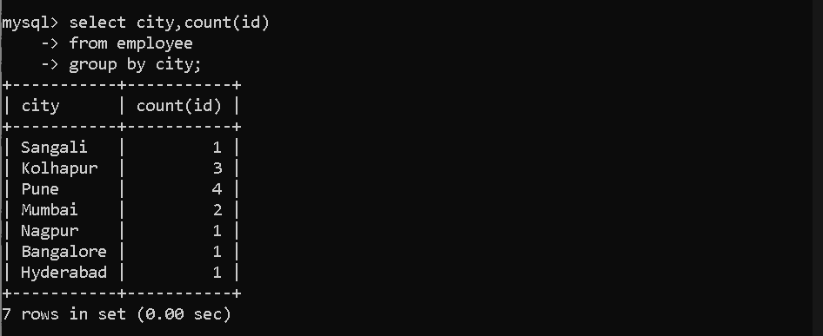
• Find the number of employees in each department.
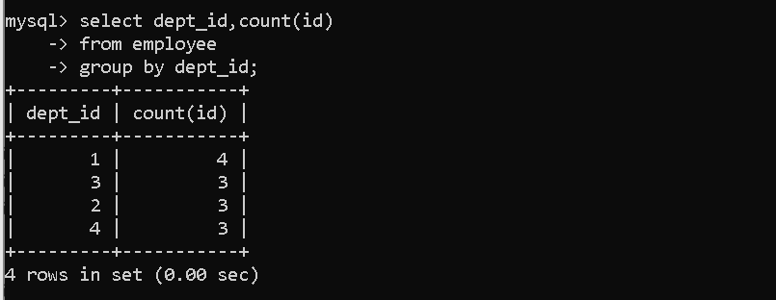
• Find the maximum salary in each department.
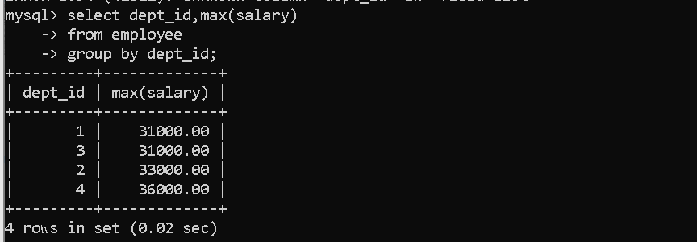
• Display the number of employees based on gender.
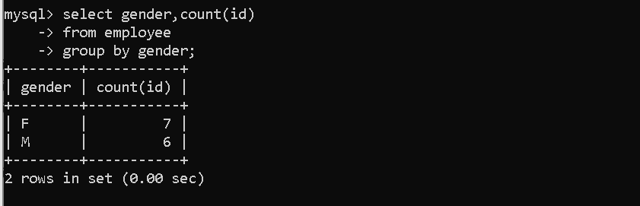
• Find the number of employees in each age group.
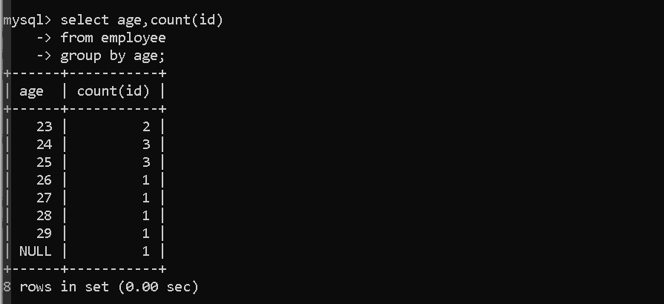
• Find the average salary of employees in each department.
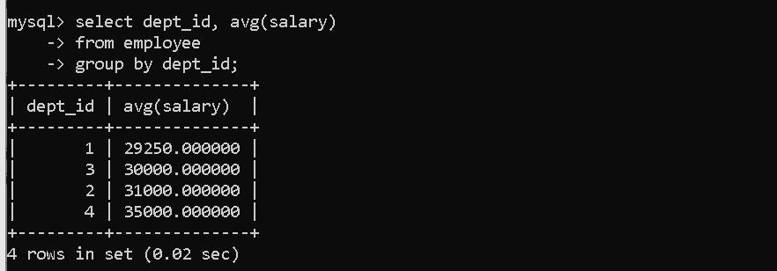
• Display departments whose average salary is greater than 30000.
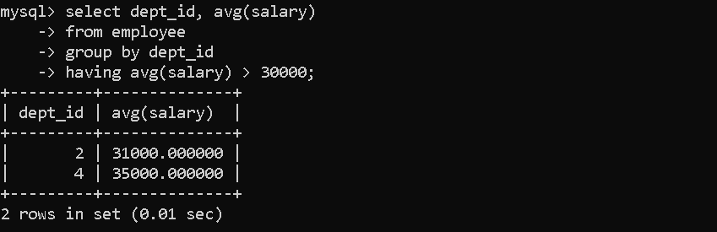
• Display departments 1 and 2 with their average salary.
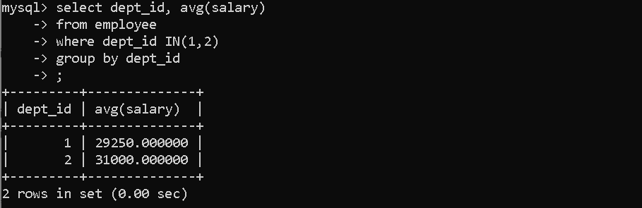
• Display departments that have at least 2 employees.
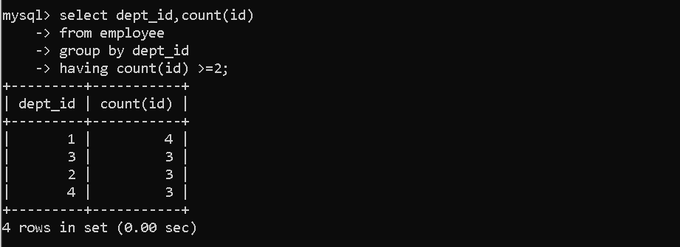
• Display departments 1 and 2 whose average salary is greater than 30000.
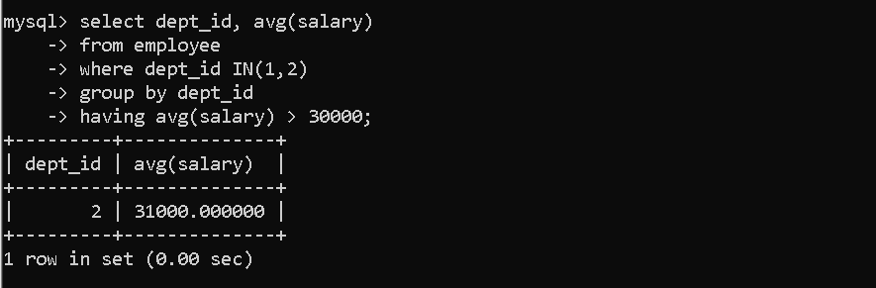
• Display departments sorted by average salary in ascending order.
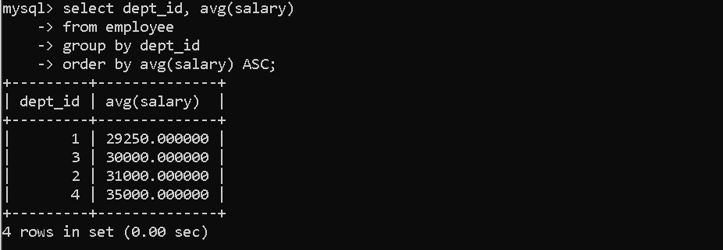
16__GROUP BY() and ORDER BY() and SUB-QUERY() :

- Find the name of the employee who has the highest salary.
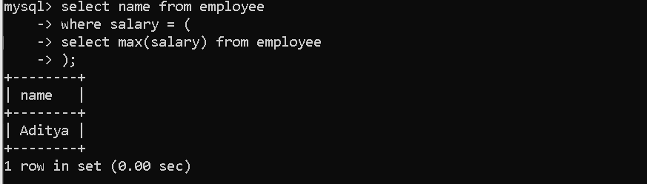
- Find the names of employees whose salary is greater than the average salary of all employees.
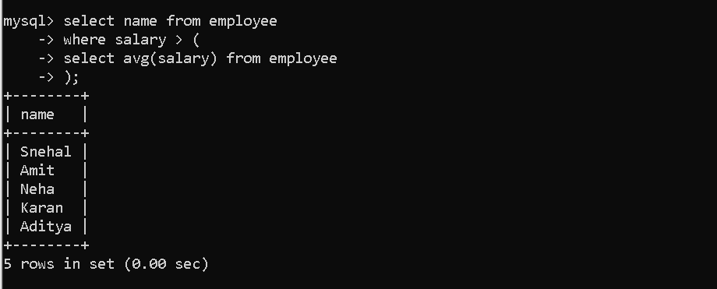
- Find the names of employees who work in the HR department.
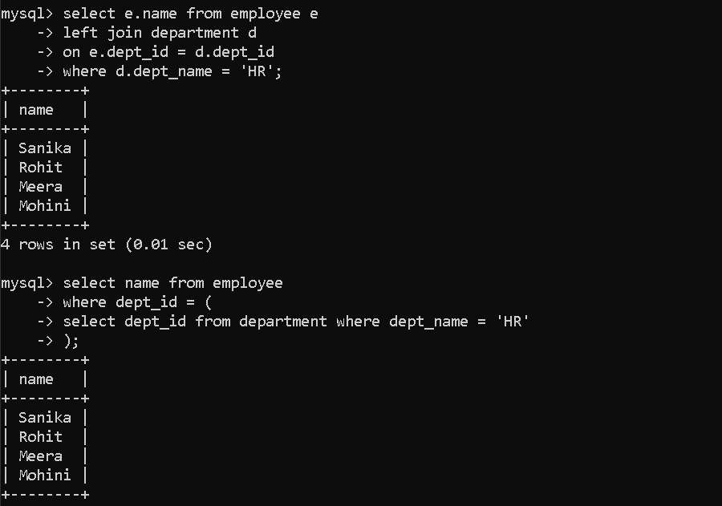
- Find the department name in which the employee with the highest salary works.
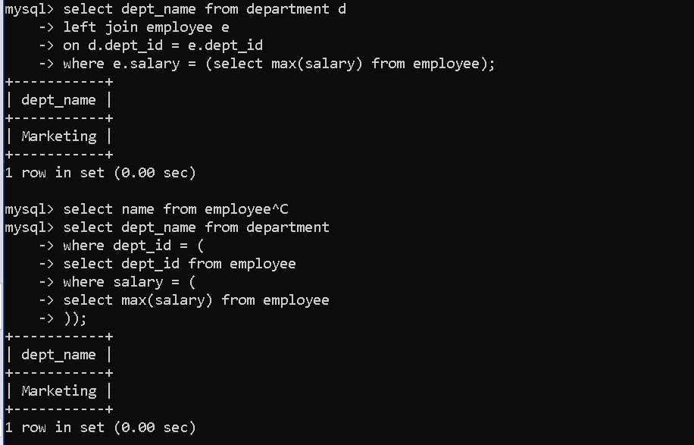
- Find the names of employees who work in departments located in Pune.
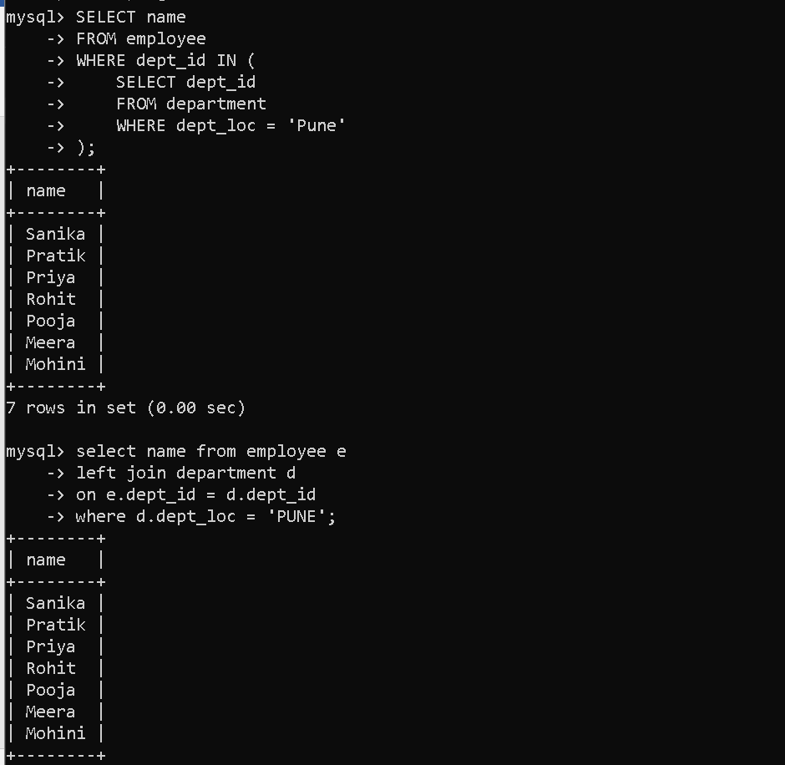

GROUP BY with Multiple Columns — Practice Questions
- Find the number of employees in each city and department.
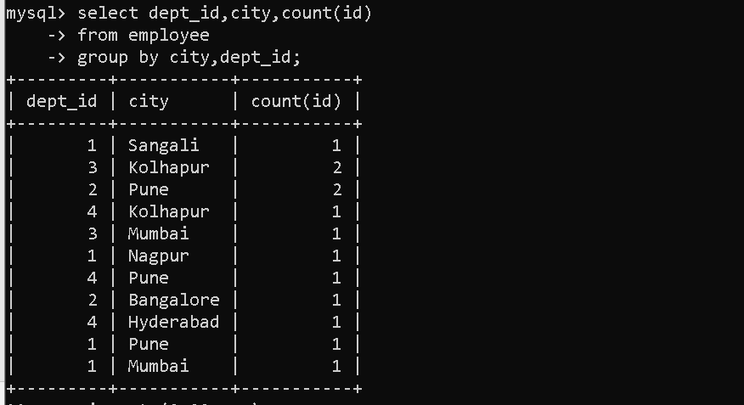
- Display department id, city, and count of employees grouped by city and department.

- Display department id, city, and count of employees sorted by department id.
